
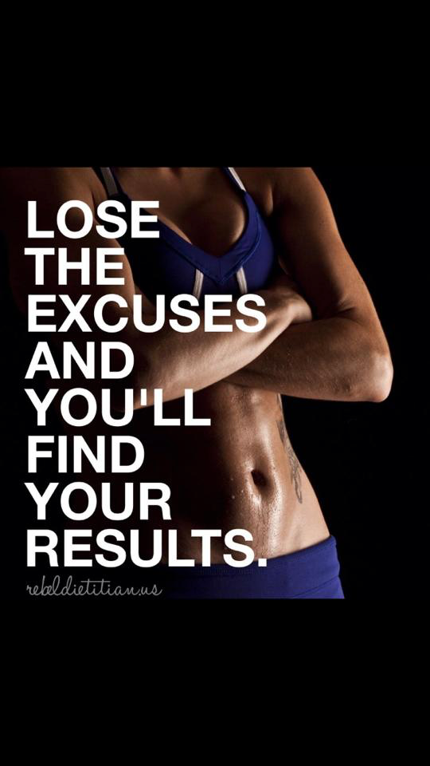
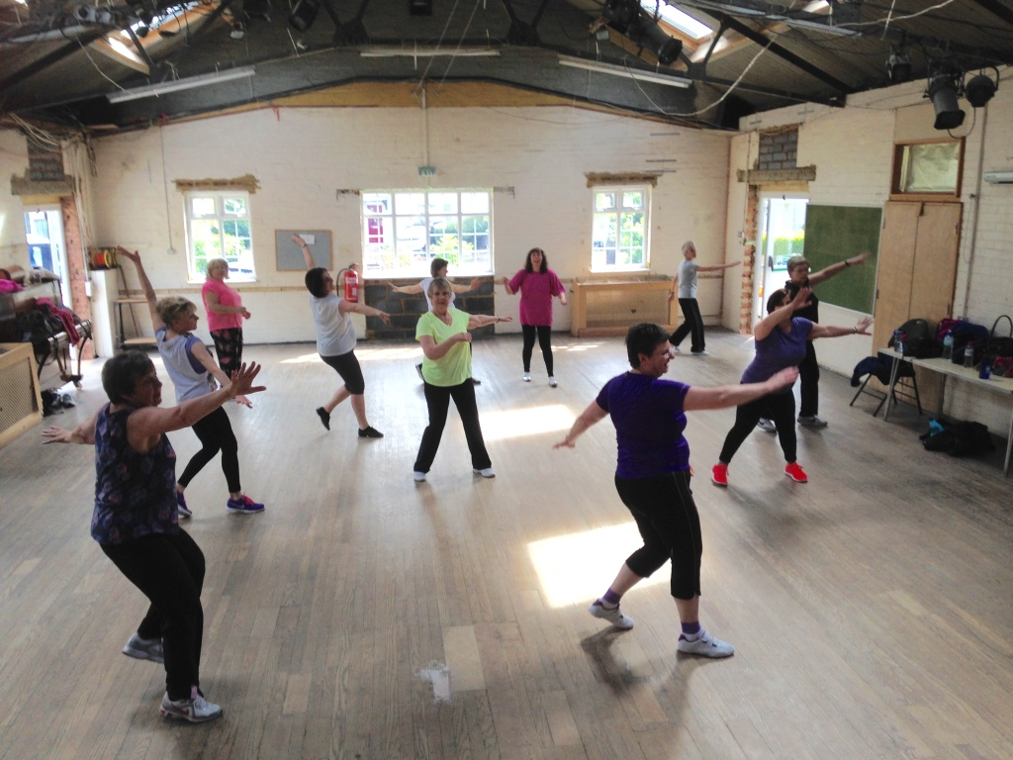
Get Fit with Vic

Charity event: Breast cancer
26th September 2015 Times 10-11:30 am. Please let me know any songs you would like me to include on the play list. Children welcome. More details to follow…

www.getfitwithvic.com
My website is now up and running and had had over 14,500 hits. Please check out some of the videos and photos from recent events and get up-to-date news on my classes.

Feedback
This is your class and your feedback is important to me. Please let me know if there is anything you would like to see improved or changed.

Zumba
Love to
Newsletter
SUMMER 2015

Class dates:

Zumba adults
Monday evenings 19:00 in Kimpton
July - 6th, 13th & 20th
August - 10th, 17th & 24th
September: 7th, then every Monday

Zumba Kids
St.Martin’sKnebwoth Village Hall Monday afternoons:
Last class 13th July, this will be a demonstration week and will be held at Knebworth Village Hall (times TBC)
Class will be back on Monday 14th September - 7th December 2015 . (12 weeks £35)

Interval training
Wednesday evenings 19:00 Kimpton
Last class 8th July

Fitsteps
Friday mornings 09:30
Last class: 10th July back on 11th September 2015 for 6 weeks course.

Zumba Gold: Class starting in Welwyn at the Whitehill Centre Tuesday mornings 09:30-10:30 first class is a free taster 8th September 2015

Facebook
You can join and keep up to date with class times/locations or any changes to the usual schedule and a bit of banter via my Zumba Facebook page: Get fit with vic (or search for Victoria Lewis)

Please join my Facebook group
Get Fit with Vic

